 | CHILDHOOD | ADOLESCENCE | YOUNG ADULTHOOD | ADULTHOOD
PEOPLE
PLACES
EXPERIENCES
DIRECTIONS | Recall for each phase of your life:  - People: who had a significant, positive effect on you  - Places: of warmth and joy  - Experiences: of elation, clarity, provision | Reflect:  - Could it have been God who was touching my life through these people, places and experiences? | 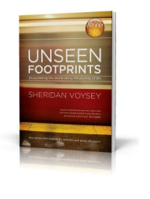  More:  This worksheet accompanies the ‘Hearing the Whispers of God’ exercise found in chapter 3 of Unseen Footprints: Encountering the Divine Along the Journey of Life, by Sheridan Voysey. For copies visit www.sheridanvoysey.com

